Rao Nauman

[Company name]  [Company address]

nauman tasawar 19p-0073

abdullah tahir 19p-0067

Using cyclomatic complexity on this CFG we get the following:

V(G) = Edges - Nodes + 2

V(G) = 16 - 13 +2

V(G) = 5

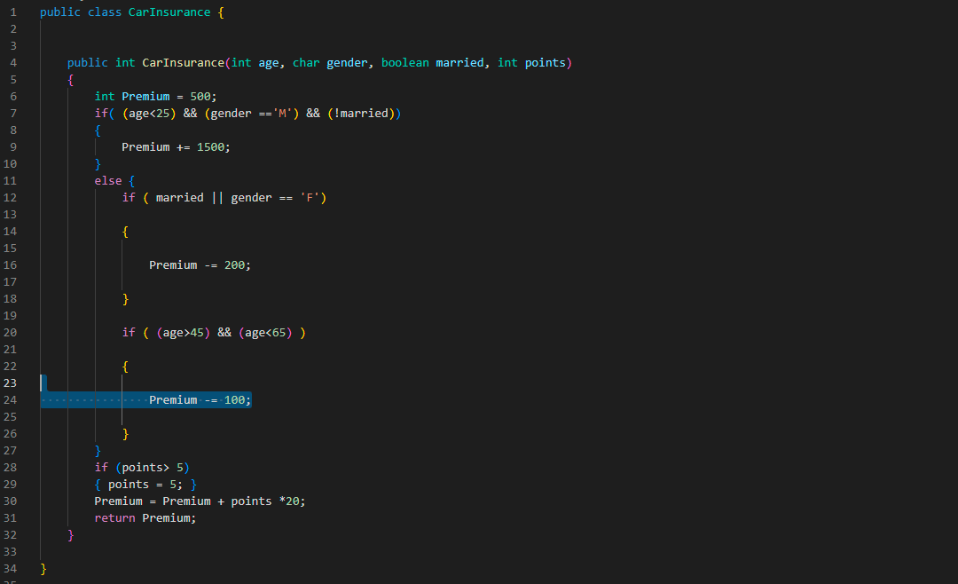

Testing:

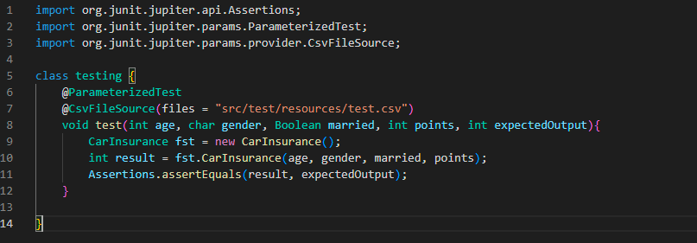

Output of Testing:

